Queensland University of Technology

Sprint 2 Retrospective

IFB299 – group 45

*Tutor: Mr Prakash Bhandari  
Date Submitted: 04/10/17*

|  |  |  |
| --- | --- | --- |
| STUDENT NAME | STUDENT NUMBER | ROLE |
| *Aiden Bird* | n9900489 | Product Owner |
| *Andrew Grant* | N9495291 | Developer |
| *Gyeongmin Jee* | N9665072 | Developer |
| *Sandra Finow* | N9144757 | Scrum Master |

sprint 2 retrospective

ifb299 – group 45

# TEAM communication

* *Excellent presentation of what you did (or/and did not do) well, and what you do differently next time for the communication within the team*
* *No spelling or grammatical errors*

# TEAM PARTICIPATION

* *All requirements or feedback from the tutor and client are well recorded and integrated*
* *Demonstrates team has discussed, agreed (or not agreed) and taken responsibility for the contents*

Requirement from the tutor and client for the sprint and weekly workshop tasks were recorded in Slack during the weekly meetings. The delegation of tasks agreed to by all members in the team meetings was recorded in the Meeting Minutes document by the SCRUM master for all members to view (Git location: IFB299-group45/doc/MeetingMinutes/Meeting_Minutes_Sprint_2.docx).

The tasks to be completed were outlined by the SCRUM master at the beginning of each meeting. The components of these tasks, who would complete each task and the timeframe in which the task had to be completed, were then discussed by the group. An example of these discussions can be seen in Figure 2 in the appendices.

After a short demo to the tutor of the websites functionality, feedback from the tutor informed the group that more time must be spent testing and correcting errors. This was to ensure that the same errors that occurred during the demo did not occur in the final release of the application. The group therefor focused more on resolving any current issues the application had. These fixes were noted by the tutor in the next demonstration of the application.

Feedback from the tutor after the first sprint plan alerted the group to various issues with the user stories. These issues included some stories not having story points assigned and an insufficient amount of work hours based on story points and the predicted time to complete the tasks. This feedback was incorporated into the sprint 2 plan as the number of tasks, the story points assigned to these tasks and the time estimated to complete these tasks is more realistic and align better with what would be expected from a team of four.

# PROJECT QUALITY CONTROL

* *All artefacts are monitored to ensure that the project complies with the quality standards.*
* *Quality standards are measurable.*

In each week during this sprint, members had to present what they will be completing each week and for the entire sprint. At the end of each week we presented what we’ve accomplished so far and what needs to be done if any problems are encountered. Upon completion of an artefact, members would let others go through a reviewing process. This ensured that the artefact that was relevant to the actual website was functional on other devices.

An improvement from the previous sprint was that more frequent refactoring process was performed to improve the code and structure quality of the website. Design was reconsidered in order to provide better quality of the website. At the end of the sprint, verification test was conducted and improvements were made to all errors found.

# INFORMING TUTOR AND CLIENT

* *All due dates of milestones and/or artifacts are clearly documented and showed to the client.*
* *The client or tutor receives all deliverables on time.*

Over the course of Sprint 2, All due dates and artefacts have successfully been documented and viewable to the client through Slack and Github. All pieces of work were submitted to slack/github before their due dates to ensure no late-submissions, and also to allow time to read over the work for any errors and reflect. No team member exceeded any due dates and all members worked well, as well as communicating efficiently to submit everything on time.

# issues raised

* *Clear descriptions of all major and minor issues or problems that have hampered (or will hamper) the progress of the project*

# APPENDICES

**Figure 1.** Example of a communications segment from one Week 1 team meeting on *Slack.*  
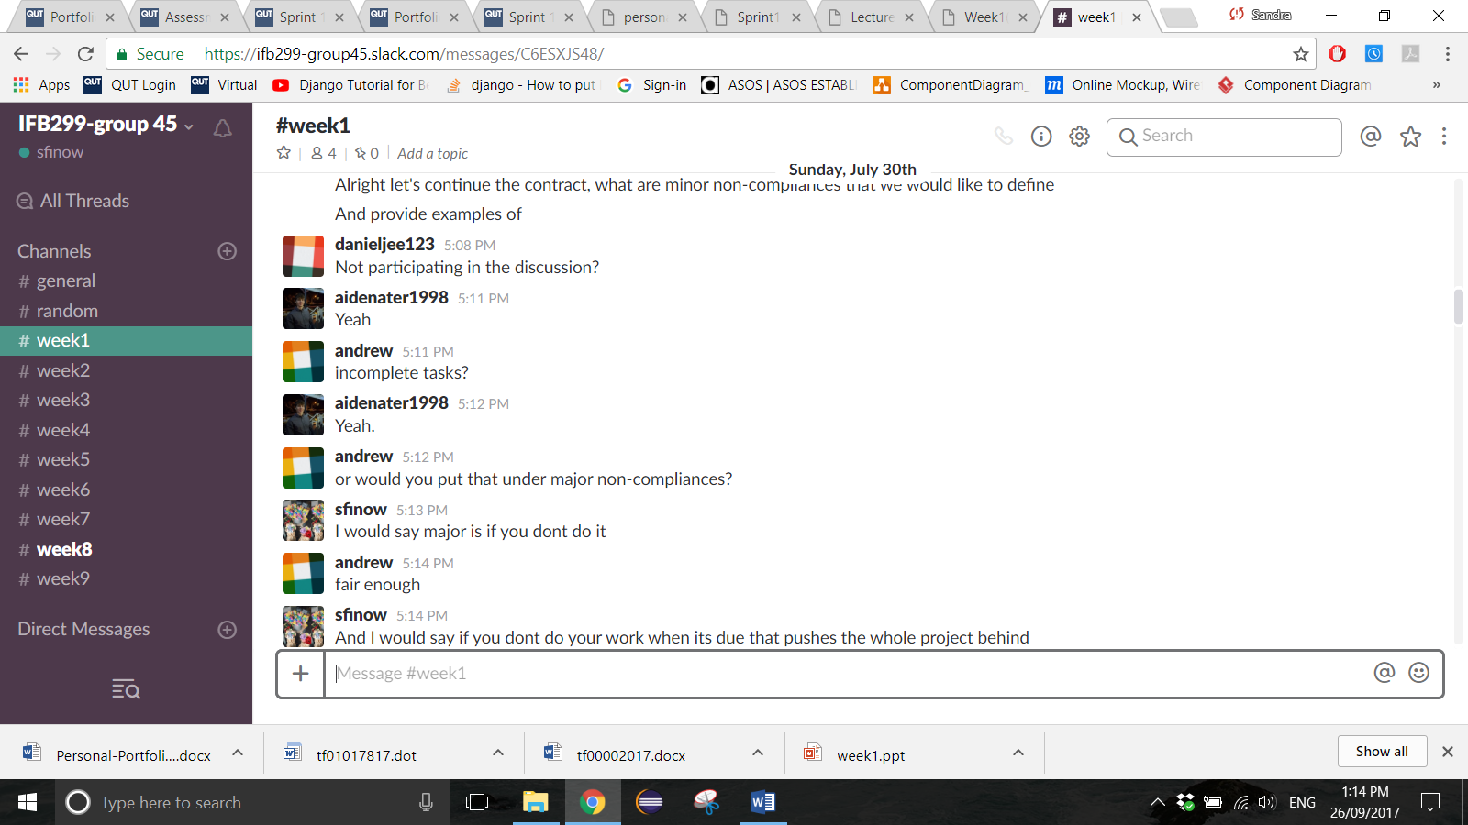

**Figure 2.** Example of a team discussion of tasks and task allocation on *Slack.*

